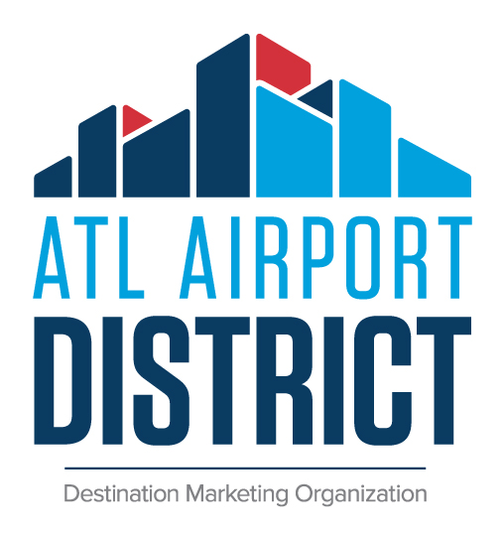
JOB DESCRIPTION: Sales Manager

DUTIES AND RESPONSIBLITIES

Essential duties and responsibilities include but are not limited to the following:
- Identify, solicit and secure new business for meetings and conventions.
- Plan and execute effective lead generation strategies (sales appointments, lead campaigns, presentations, trade shows, site visits, etc.). Follow up on leads and inquiries with the appropriate action in a timely manner.
- Ability to achieve 90% of production goals and fulfill activity goals as established by management.
- Ability to operate and sell to multiple market segments.
- Manage and maintain existing accounts in assigned segments.
- Assist in the implementation of the sales and marketing plan and strategies to promote the destination to convention business.
- Ensure effective communication is maintained with clients, hotels, and convention center.
- Oversee the coordination and transition of clients from account sales to account services, in conjunction with the director of convention services.
- Contribute to the overall success of the organizations goals.
- Ability to work with people at all levels.
- Identify and explore emerging markets. Stay current on competition, industry trend, and practices.
- Understanding of the market and its facilities.
- Exhibit a positive and involved team attitude.
- Actively participates in community and trade organizations that best fulfill the mission and goals of the organization.

Client, Industry and Community Relations
- Participate in meetings with partner hotels.
- Represent the DMO at the local, state and national level by maintaining active memberships in pertinent industry associations, and attending industry meetings to promote sales and services.
- Maintain close working relationship with the Georgia International Convention Center (GICC) staff, partner hotels, Hartsfield-Jackson Atlanta International Airport, partner city officials.
- Identify, recruit, and encourage local stakeholders who can influence targeted clients on site decisions.
- Maintain well-informed working knowledge of all related GICC, hotel, restaurant and other stakeholder facilities and services.

Reports To: Director of Sales

QUALIFICATIONS
- Requires knowledge of general sales techniques.
- Bachelor’s degree from an accredited institution in business, hospitality, marketing, communications or related field preferred.
- Minimum 5 years direct sales experience. Hotel, convention center, convention bureau or tradeshow/meeting planning experience preferred.
SKILLS / KNOWLEDGE / ABILITIES REQUIREMENTS
- Proven skills in sales lead development, persuasion and negotiations, relationship building.
- Excellent communication skills and demonstrated presentation skills.
- Ability to develop and write effective proposals, reports, sales plans and business correspondence.
- Requires effective oral and written communication skills.
- Ability to hear, speak, read, and write English fluently.
- Requires highly developed customer service skills.
- Experience with MS Office applications, Simpleview or other CRM software.
- Ability to travel by air and personal vehicles.
- Must possess a valid driver’s license.
- Ability to work evenings and weekends.
- Strong national, local and state client base desired and considered a plus.

COMPENSATION

Competitive salary commensurate with experience and hospitality industry standards

Well-qualified applicants should submit their resume and cover letter to sales@atldistrict.com

The ATL Airport District is an equal opportunity employer

